# Bot Instructions

1. Go to <https://qnamaker.ai>
2. Sign in with your Microsoft Azure Subscription login name and password.
3. Click Create a knowledge base

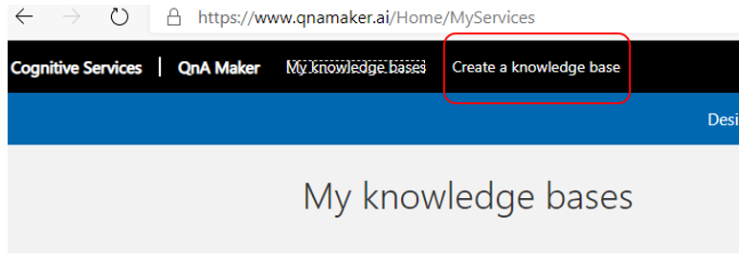

1. Click Create a QnA service

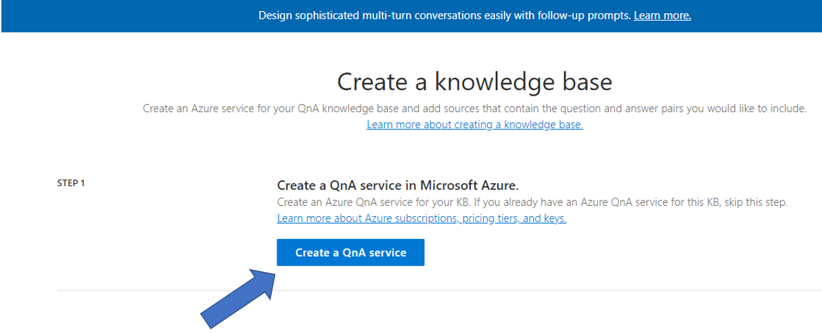

1. A new browser tab will open, and you will be directed to it. Fill out the information to create the QnA service in your Azure subscription. A sample is shown below. Click Create when done.

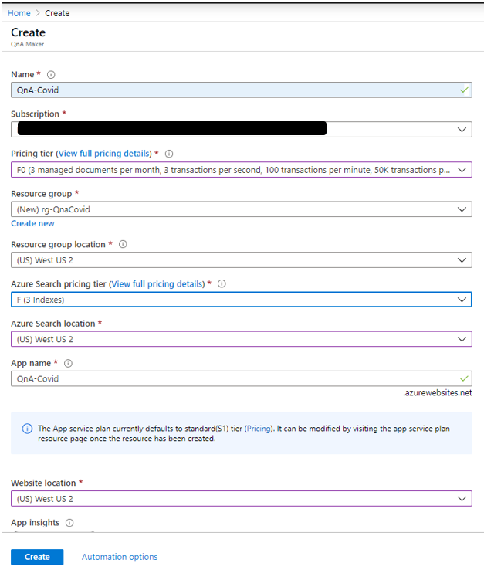

1. Wait until deployment is done.

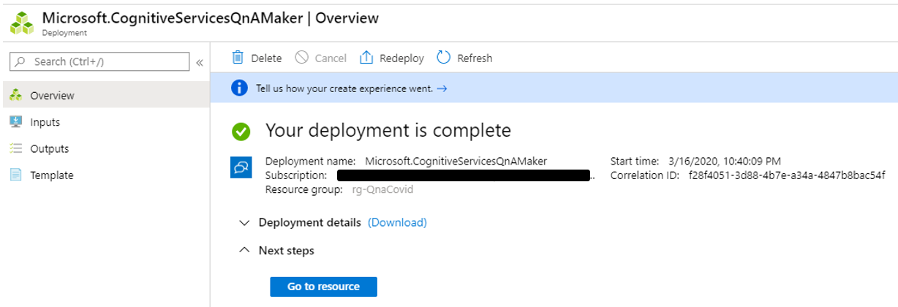

1. Go back to the QnA Maker browser tab and click Refresh in Step 2.

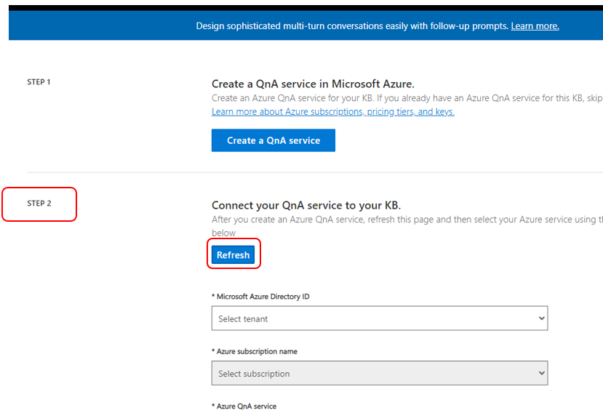

1. Select your Azure Active Directory ID and Subscription name. Then select the new QnA service you created in step 5. It should show up in the dropdown.

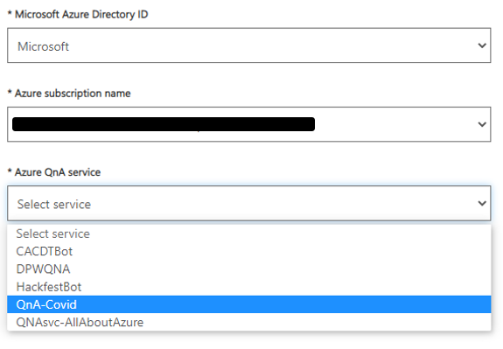

1. Select Language.

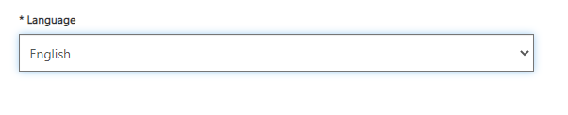

1. Name you KB in step 3.

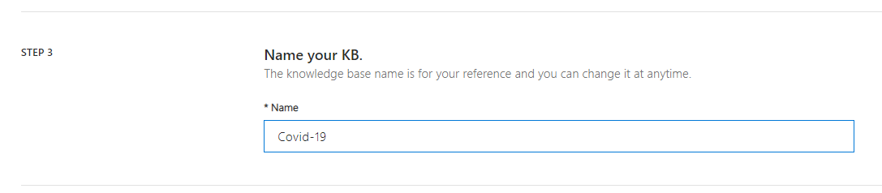

1. Populate your KB in step 4. Enter a URL from your website with Covid FAQ or use CDC’s URL, which is - <https://www.cdc.gov/coronavirus/2019-ncov/faq.html>

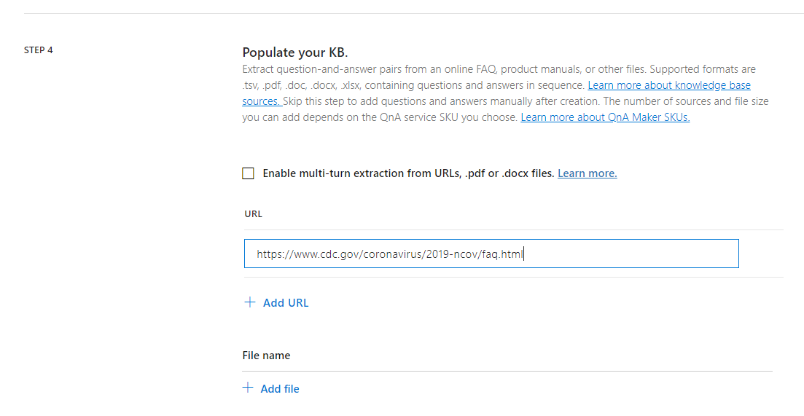

1. Add additional URLs or Files (optional)
2. Add personality of Bot (optional but recommend picking one).

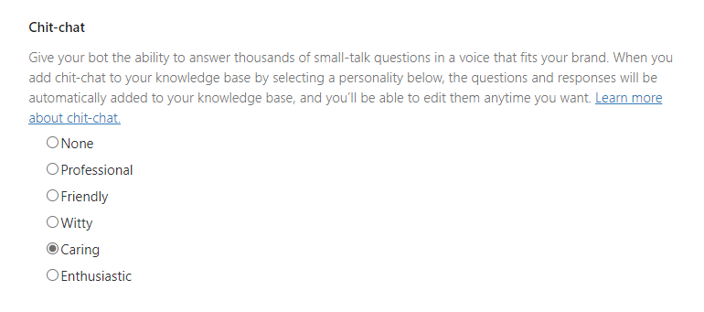

1. Click Create your KB in step 5.

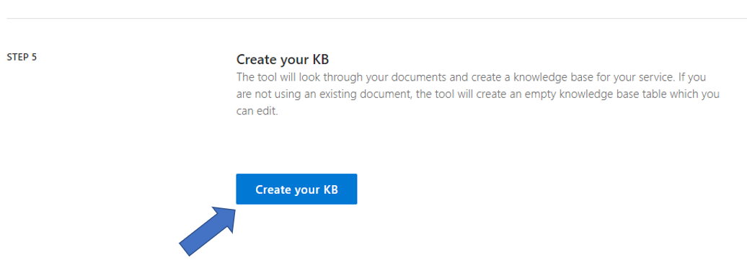

1. Click Save and train if you made changes to the Q&A pairs. Otherwise, skip to step 16.

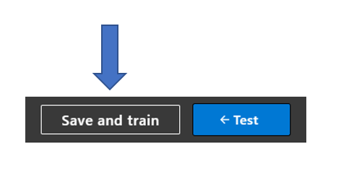

1. Click Publish.

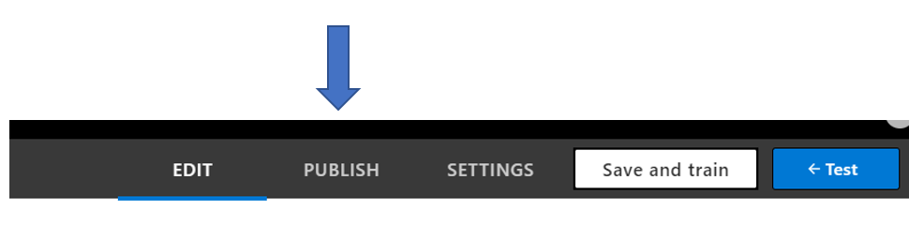

1. Click the Publish button.

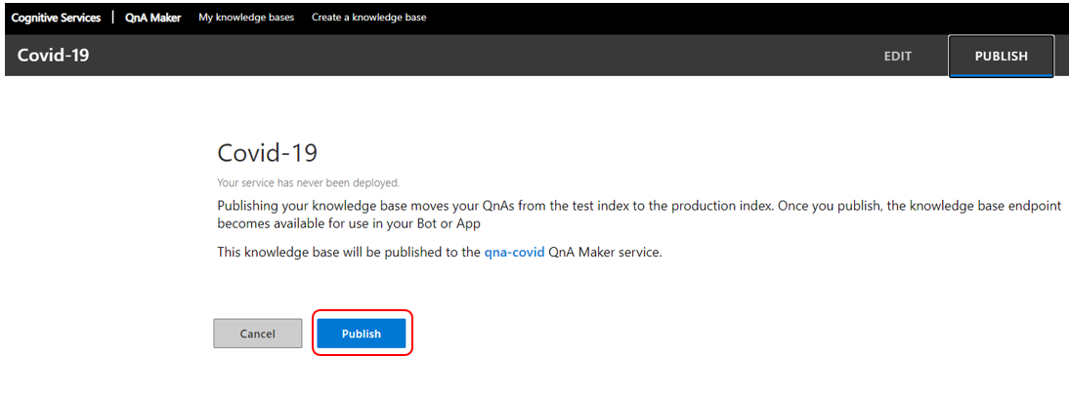

1. Click Create Bot.

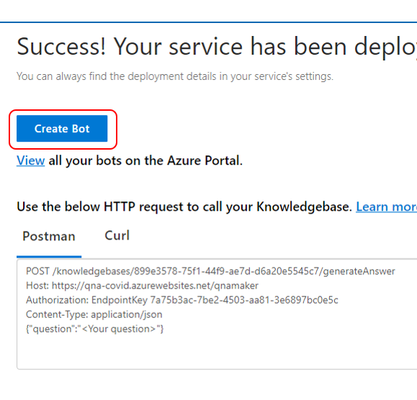

1. A new tab with the Azure Portal will open. Accept all defaults but create the Bot and its resources in a region closest to you. Create an App service plan closest to you as well. Click OK.

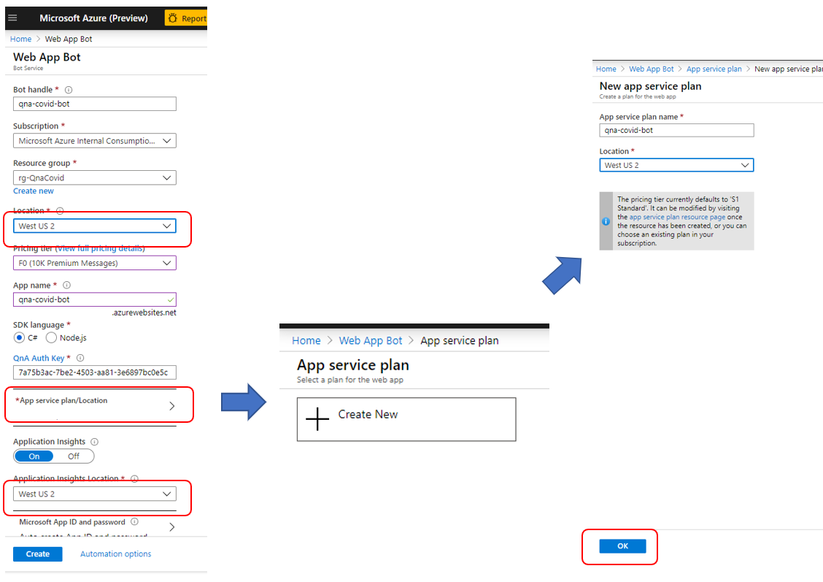

1. Click Create.
2. Monitor the Bot creation. (use the bell icon at the top right corner). When it is done, click Go to resource.

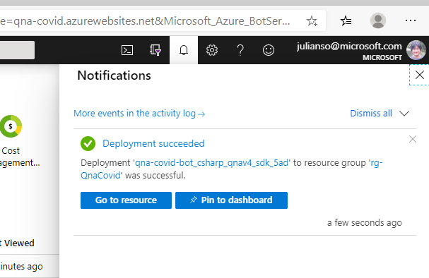

1. Select Build, then click Download Bot source code.

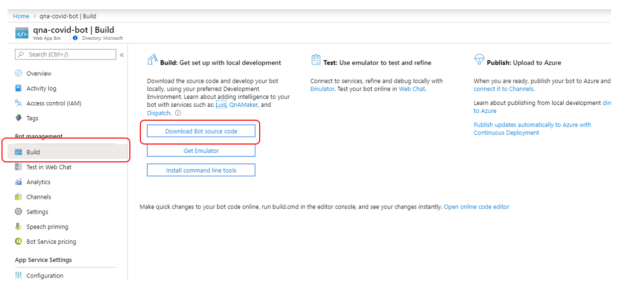

1. Select Yes to include app settings.

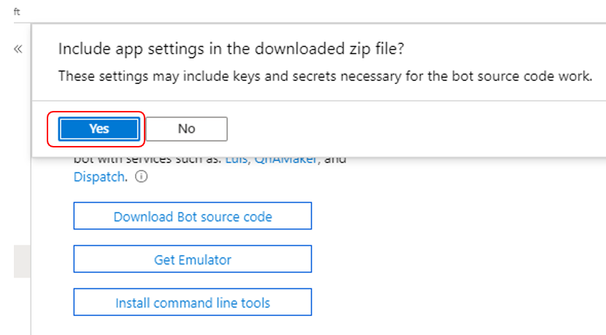

1. When download is ready, click Yes to download the file. This will download a zip file to your downloads folder.

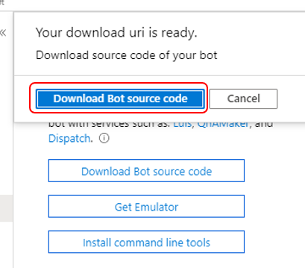

1. Click Channels and then click Get bot embed codes.

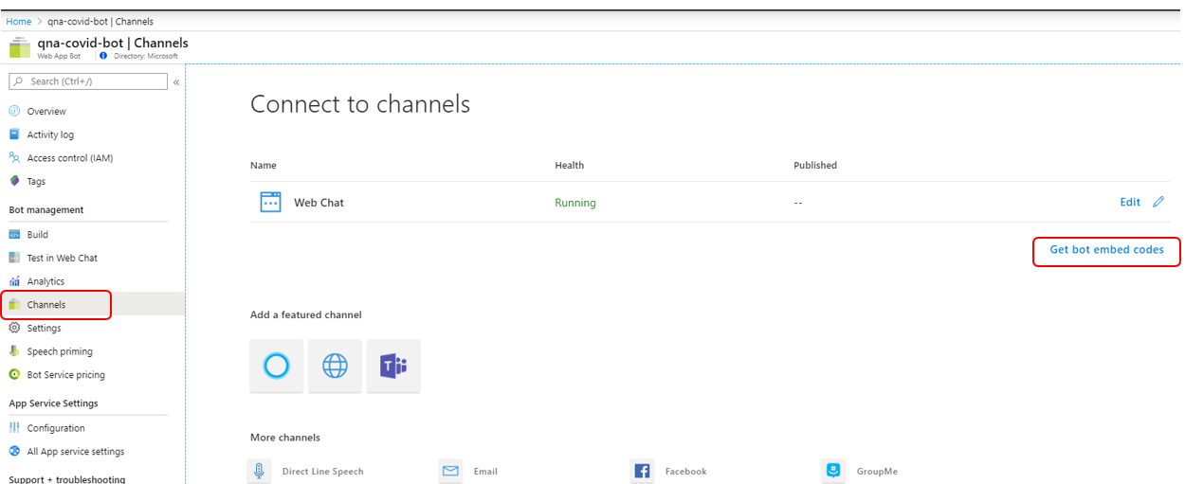

1. Click “Click here to open the Web Chat configuration page >”

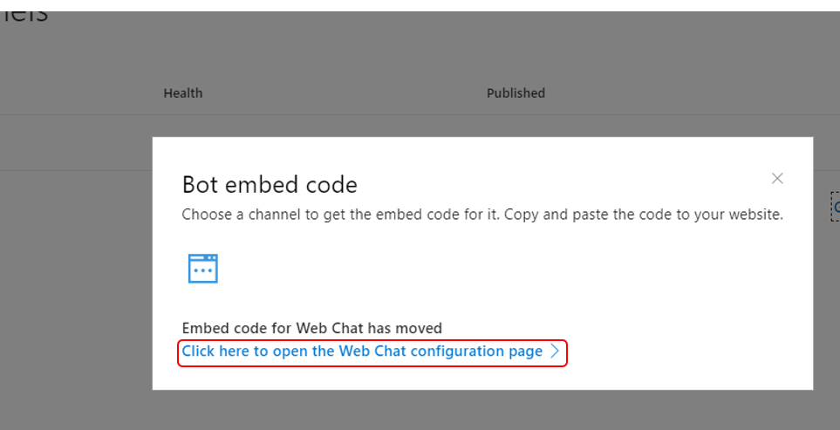

1. Click Show to get the Secret keys, copy it to notepad.

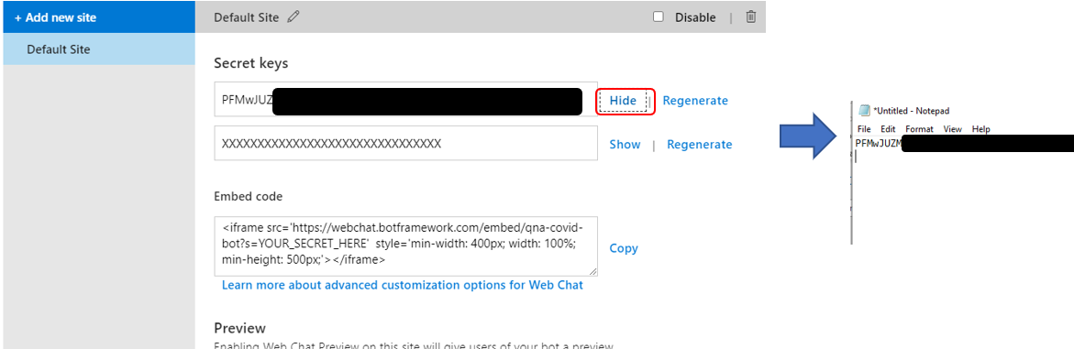

1. Click Copy for the Embed code, and copy it to notepad as well.

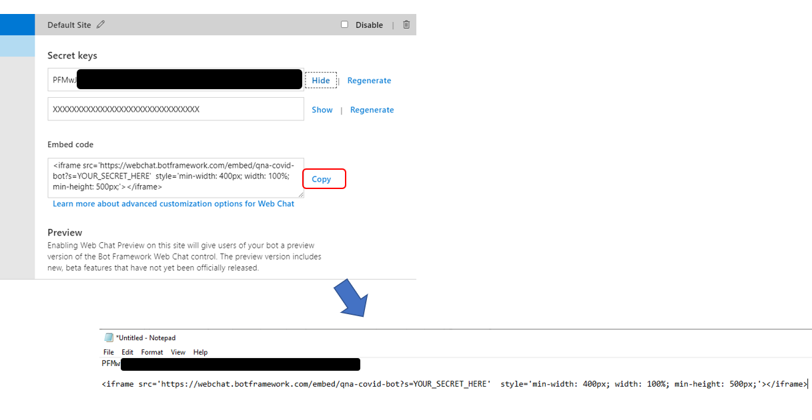

1. Take the key and put it into the embed code where it says YOUR_SECRET_HERE. (ps: this is a fake key for illustration purposes).



1. Final embed code should look like this.



1. The <iframe> embed code is what you will insert in your web page source (or master page). Save it for now.
2. Click Done.
3. Click Home at the top left corner.

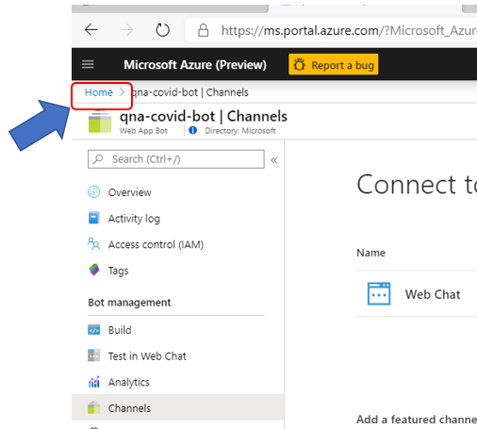

1. Locate the Resource group for your Bot assets. It should be in the Recent resources list. Make sure you select the Resource group object type.

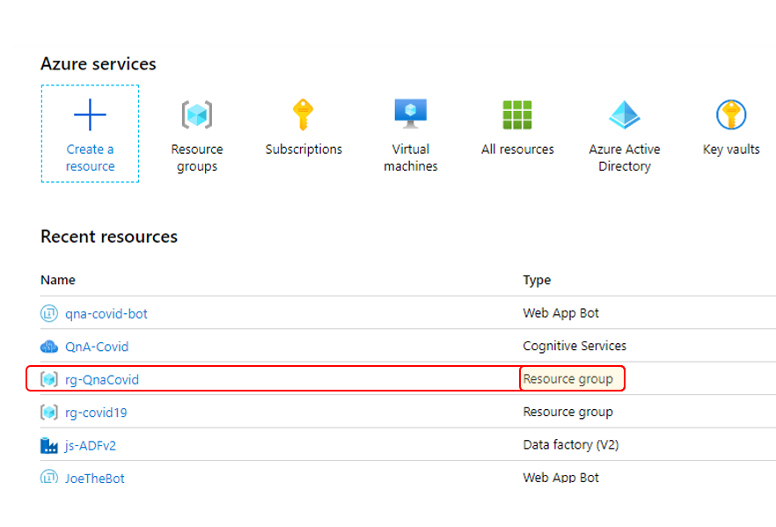

1. You should see all the assets required for your Bot. Click on the App Service object.

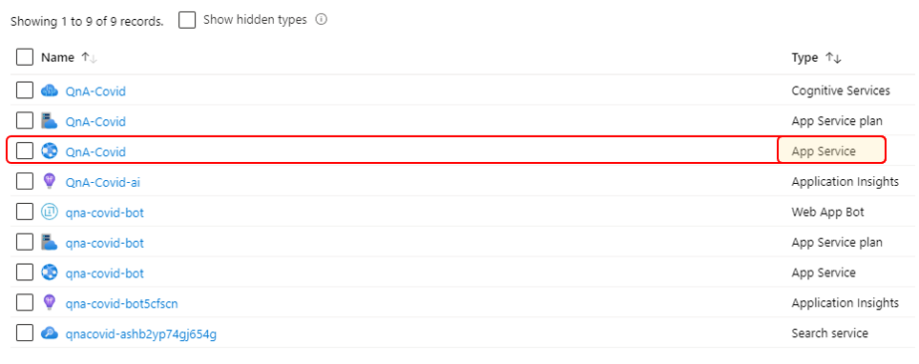

1. Click Get publish profile. This will download a file to your downloads folder.

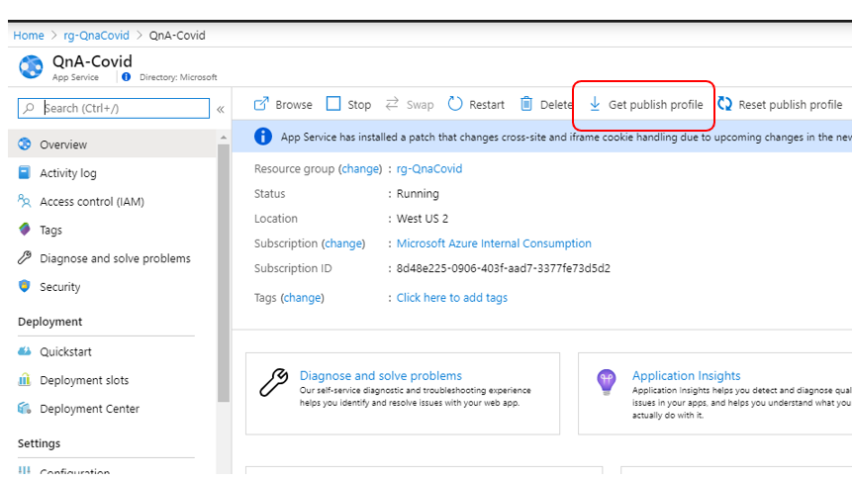

1. Copy the zip file (from step 26) from your downloads folder to a new directory (you can name that directory Covid).
2. Copy the publish profile (from step 36) from your downloads folder to the same directory as the zip file.
3. Unzip the contents of the zip file.
4. Launch Visual Studio and select Open a project or solution ([download and install Visual Studio 2019 Community Edition](https://visualstudio.microsoft.com/downloads/) if you do not have Visual Studio).

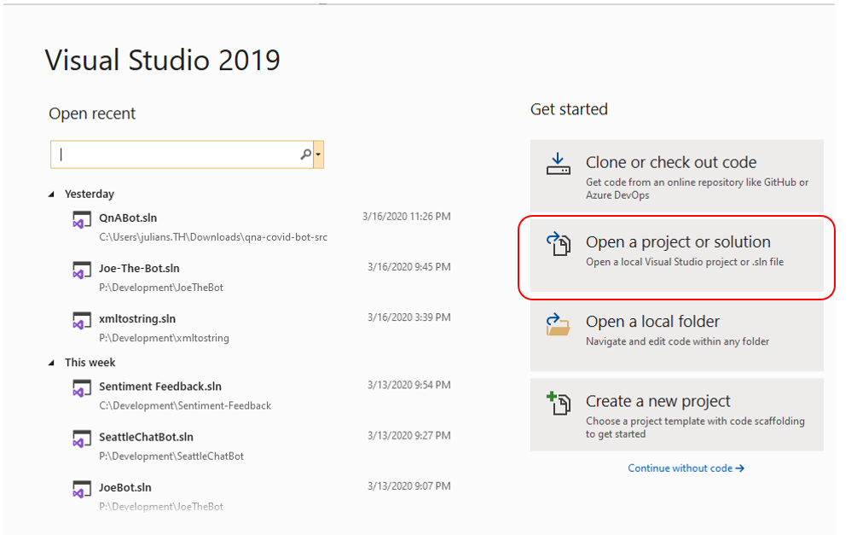

1. Open QnABot.sln.

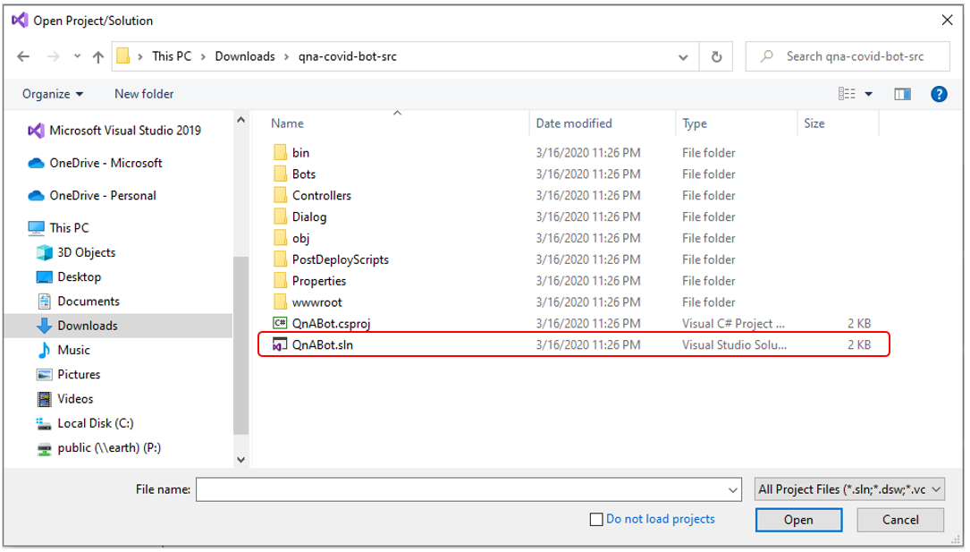

1. Click Build -> Publish QnABot.

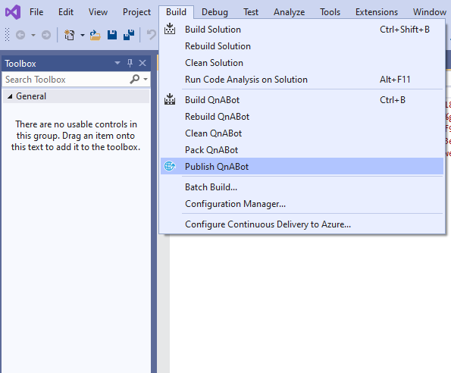

1. Select Import Profile.

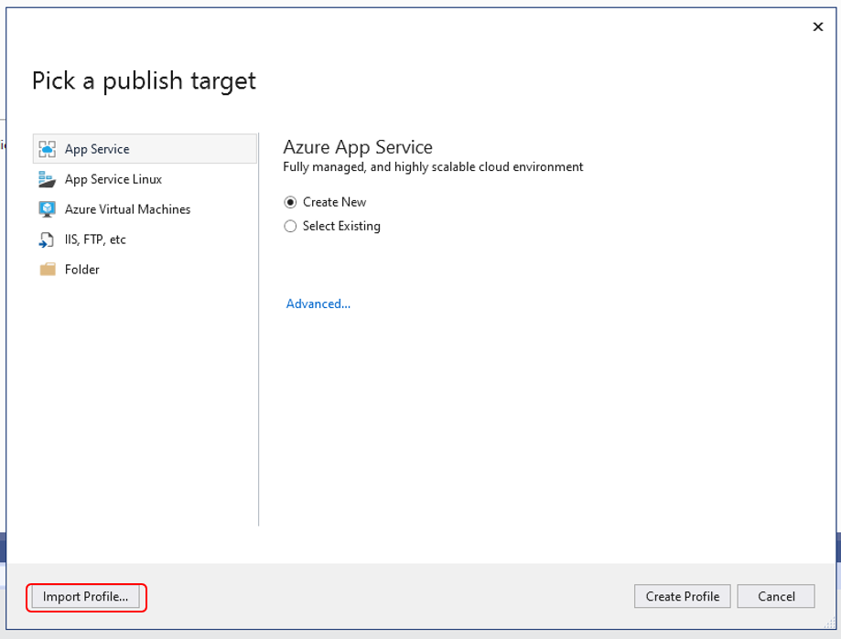

1. Pick the Publish profile you downloaded in step 36.
2. Click Publish.

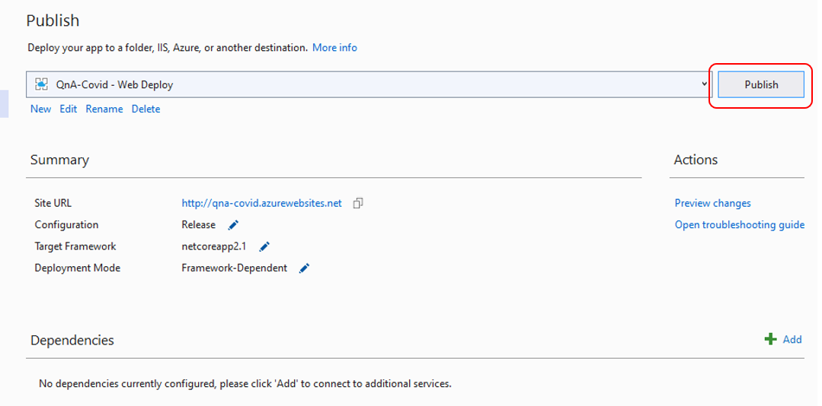

1. When you bot is successfully built and deployed, you will see this page.

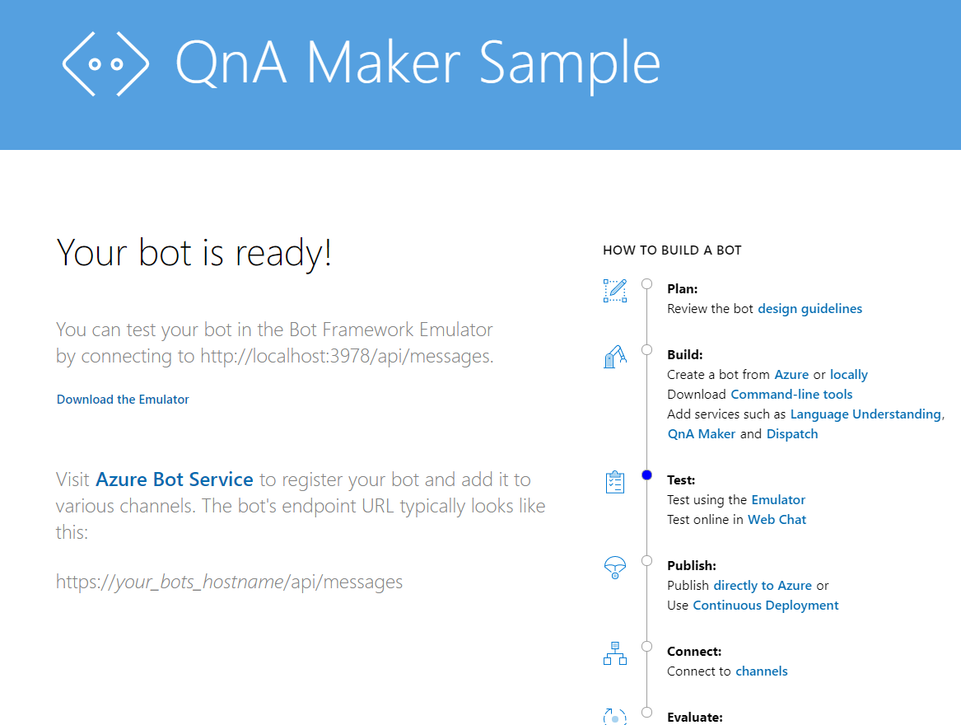

1. Close all browsers, save your Visual Studio project and exit Visual Studio.
2. Insert the <iframe> embed code from step 31 into your web page or master page.